TrustCore Project Overview
Last updated 22 October 2026. Prepared by Generation Web.
This is the short version of what TrustCore is, how it's put together, and what was handed over. Two companion documents go further: the User Guide for people working in the dashboard, and the Developer Guide for anyone changing the code.

What TrustCore does
TrustCore (trustcore.ch) is an insurance comparison and offer platform for the Swiss market. An advisor records a customer's details, the system builds comparison offers across insurers and product lines (health, accident, legal protection, liability, life and so on), and each offer ends up as a PDF tied to that customer. Staff manage customers, offers, insurers and products from one admin dashboard, and customers can log in to see their own offers.
What sets it apart from a typical admin app is how flexible the product catalogue is. Insurers, coverage levels, deductibles and the fields on each form aren't hard-coded. They live in a configurable content system the code calls "Collections", so staff can add a new product or a new form field from the dashboard without a developer or a deployment. Almost everything else in the system is built on top of that idea.

How it's built
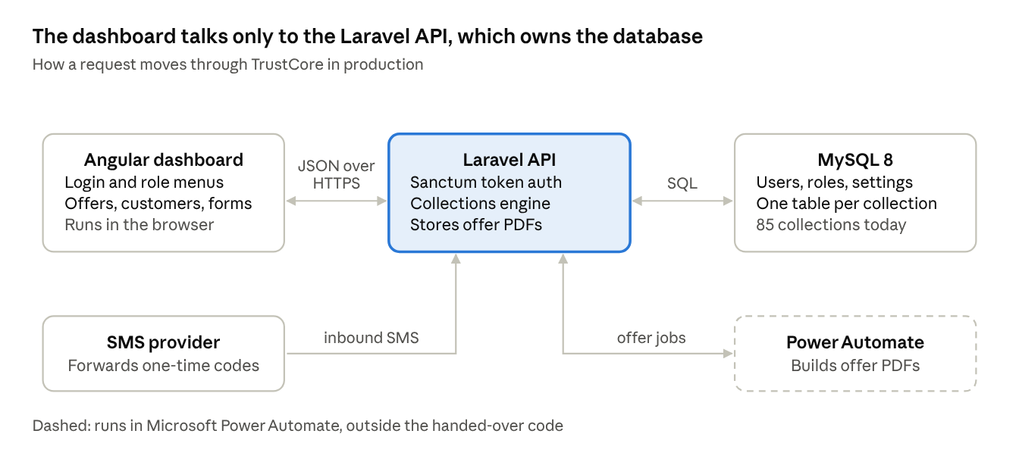
TrustCore architecture · dashboard, API, database, SMS
Two pieces, deployed separately but served from the same domain:
Part | Built with | What it does
Frontend | Angular 15 on the ngx-admin (Nebular) template, with ng2-smart-table for data grids, Leaflet for maps, and jsPDF and SheetJS for exports | The whole dashboard: login, menus, offer and customer screens, and the template field builder
Backend | Laravel 11 on PHP 8.2 or newer, Sanctum for API tokens, MySQL 8 | The REST API, authentication, the Collections engine, PDF storage, and an inbound SMS hook that captures one-time codes
There's no separate marketing site in the code. What visitors see at trustcore.ch is the dashboard's login screen.
One job happens outside both pieces: building the offer PDF. When someone creates an offer, Laravel saves it as "Creating Offer" and passes its ID to a Microsoft Power Automate flow. The flow prepares the document and posts it back, and the offer moves to "Ready", or to "Failed" if the flow reports a problem. Of the 53 offers in the export, 40 reached Ready, 11 failed and 2 never came back. The flow lives in Power Automate rather than in the handed-over code, so it needs its own review. Section 5 of the Developer Guide covers the hand-off in detail.

What was handed over
The handover package has three parts:
Item | What's in it
Trustcore-Frontend/ | The Angular source. This is the trust-core-updates branch, which turned out to be the most current of the versions we were given (more on that below).
Trustcore-Backend/ | The Laravel application exactly as it runs in production, minus the vendor/ folder. Running composer install rebuilds that from composer.json and composer.lock.
TrustcoreDB.sql | A full export of the production database taken on 22 October 2026, about 80 tables.
A few things about how we got here, since they affect whoever picks this up next:
- The live server only had a compiled build of the frontend, not its source. The source came separately, in two versions. We built and ran both, and the trust-core-updates branch is clearly the newer one: 19 more source files, a dedicated user management module, translations, and work in progress on role permissions. The older master copy shouldn't be used for new work.
- One extra archive we received (trust_core.zip) turned out to be a second copy of the backend, not the frontend. Its git settings contain a GitHub access token in plain text. We didn't use that archive, but the token should be revoked on GitHub.
- Both halves were set up from these files on a clean machine and checked end to end, including a real login against the imported data.

Production environment
What | Where
Site | https://trustcore.ch
Hosting | Hoststar shared hosting (lx54.hoststar.hosting)
Database | MySQL 8.0.42
Database admin | phpMyAdmin, through Hoststar
Hosting control panel | my.hoststar.ch
Logins for all of the above are kept in the project's password manager and aren't repeated here. File access is over SFTP, which on this host is transfer only, with no shell. Shell access has to be requested from Hoststar and arrives as a temporary password that expires after a few hours.

The data today
Record | How many
Users | 23, across three roles (admin, employee, customer)
Collections | 85, of which around 40 are insurer or product line families with their own coverage levels, deductibles and waiting periods
Offers | 52, each with a PDF (112 PDFs on disk once older versions are counted)
Templates | 35

Before anyone changes anything
The full list lives in the Developer Guide. These are the ones worth knowing at project level:
- Role permissions are only partly enforced. Menus hide what a role shouldn't see, but the check that should stop someone typing a URL directly is unfinished, and the backend trusts whatever role the browser says it has.
- Only build the frontend from Trustcore-Frontend/. That source correctly targets trustcore.ch. The older master copy isn't part of the handover, and its production settings point at a server that's no longer in use.
- Debug mode is on in production, which can show error details to visitors.
- A 306 MB site.zip from July 2025 sits in the public web root. It may be downloadable by anyone who guesses the name.
- There's test data in production: around 15 test templates and a test@test.com account.
- The offer automation needs tightening. The address that starts the Power Automate flow is hard-coded in the backend, the endpoints the flow reports back to aren't protected, and an offer whose flow never answers stays at "Creating Offer" with nobody told.

Where to go next
- Working in the dashboard: the User Guide.
- Running or changing the code: the Developer Guide.

